mangoO Microfinance Management User Manual for v1.0.0

mangoO Mircofinance Managment is a software solution for small scale micro-finance institutions. It was first developed for Luweero Diocese SACCO (Savings and Credit Cooperative) in Luweero, Uganda.

Getting Started
As mangoO is based on web technology, you will need a web browser to use the program. It is recommended to use Mozilla Firefox, Chrome, or Chromium. Your administrator should have provided you with an address or link to gain access to mangoO.
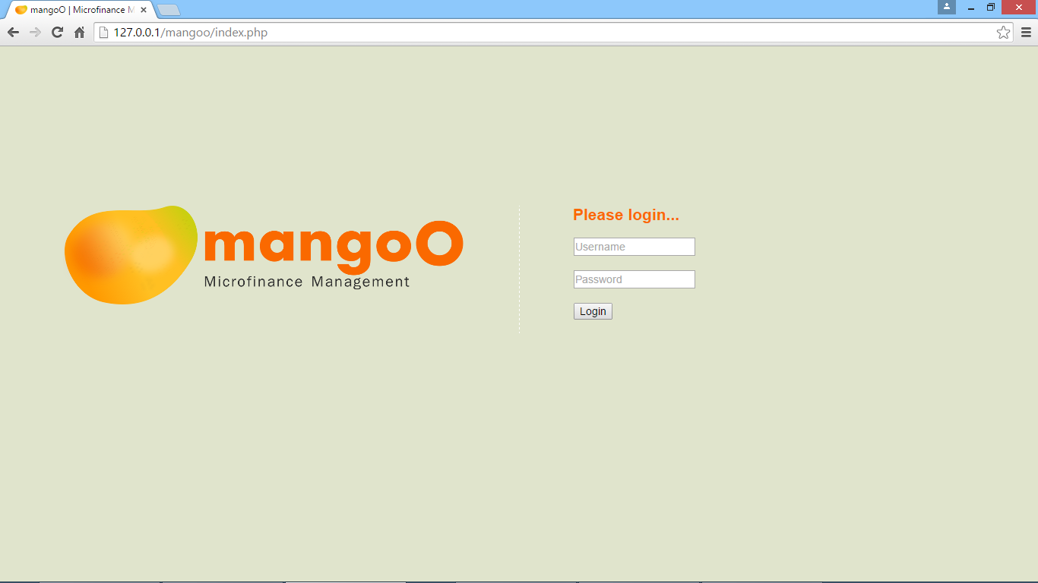
On the start page of mangoO, please provide a valid user name and password. In case you do not possess such login information, please contact your system administrator.
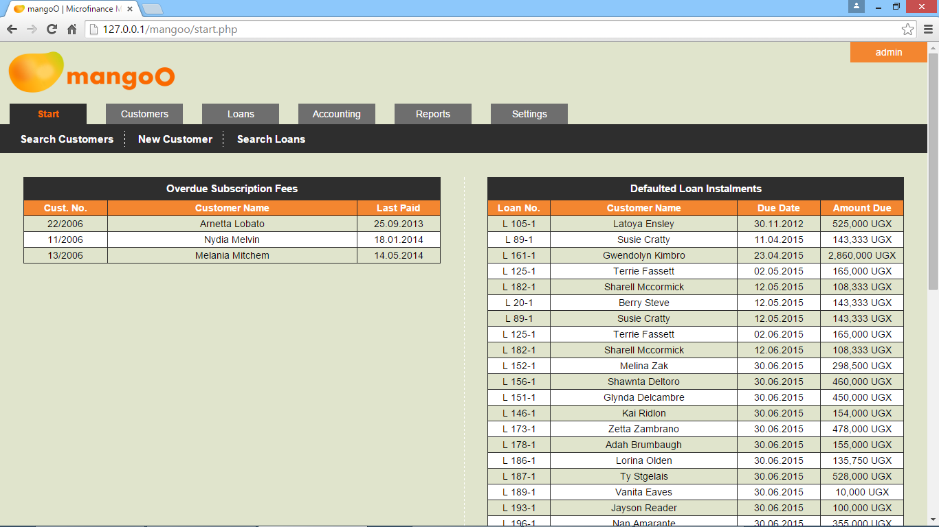
After logging in, the system will take you to the user dashboard. Here you will find two quick information tables.
The one on the left lists all customers whose annual subscription has expired. In order to access a customer's record, click the respective customer number.
The table on the right shows all currently defaulted loan installments. In order to access the loan's record, click the respective loan number.
The options in the upper menu bar give you quick access to the most frequently used functions. Search Customers accesses the customer search form (see 2.1), Search Loan the loan search form (see 4.1), and New Customer allows you to create a new customer record (see 2.2).

Customers
Under the tab Customers you will find all tools for managing customer records.

Customer Search
The customer search form allows you to search the database for customers. The upper input field is used to search for a customer by number. Since customer numbers are unique identifiers, as long as the customer number exists, you will be taken directly to the respective record. If a given number does not exist in the database, an error message will appear.

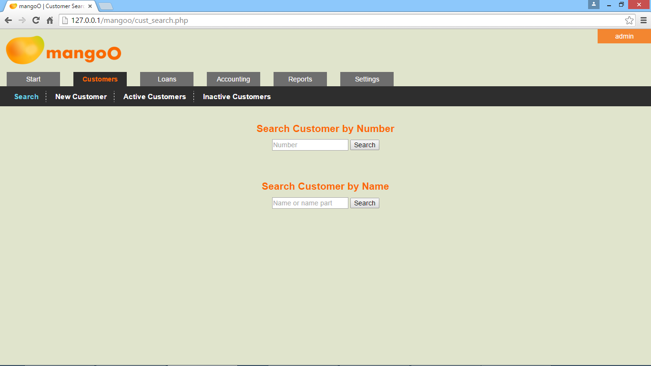
The lower input field allows for searches by name or name parts. As names are, by nature, ambiguous, this search will take you to a result page. mangoO will search for any customer on the database whose name contains the given search criteria, regardless of its position within the name. For example, a search for the string shu will yield Shumate as well as Joshua. If a given search criteria does not match with any name in the database, the search result list will remain empty.
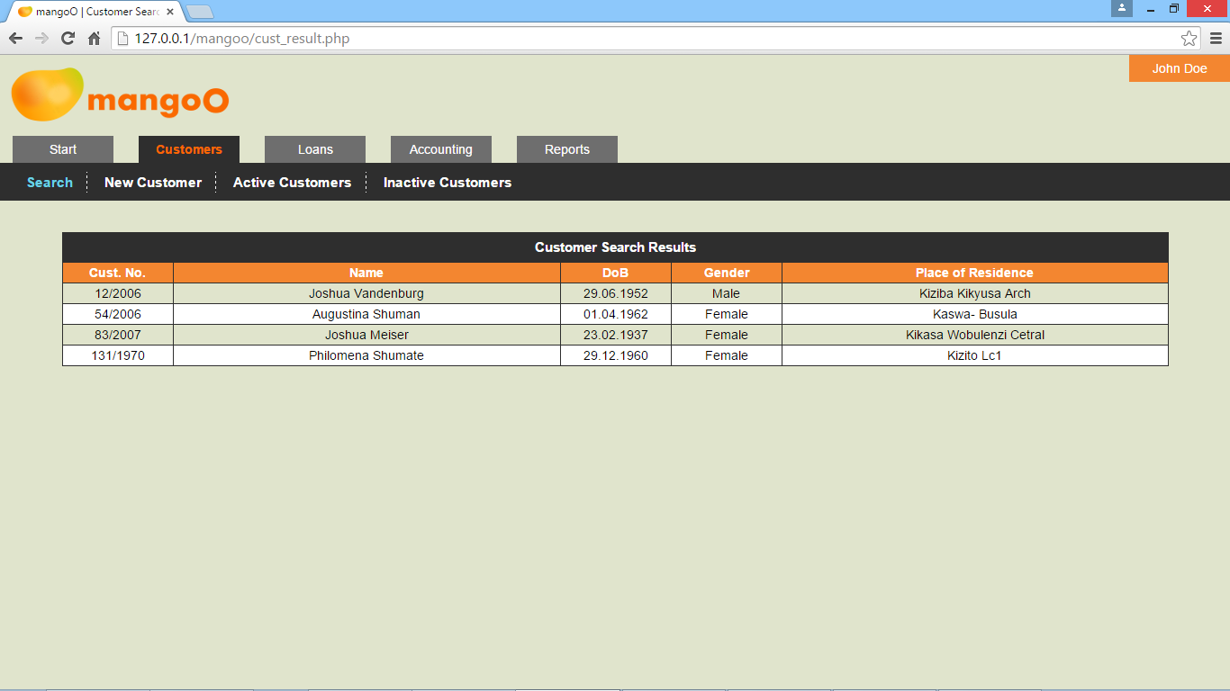
In order to access a customer's record from the search result page, click the respective customer number.

New Customer Record
This page allows you to enter a new customer record into the database.
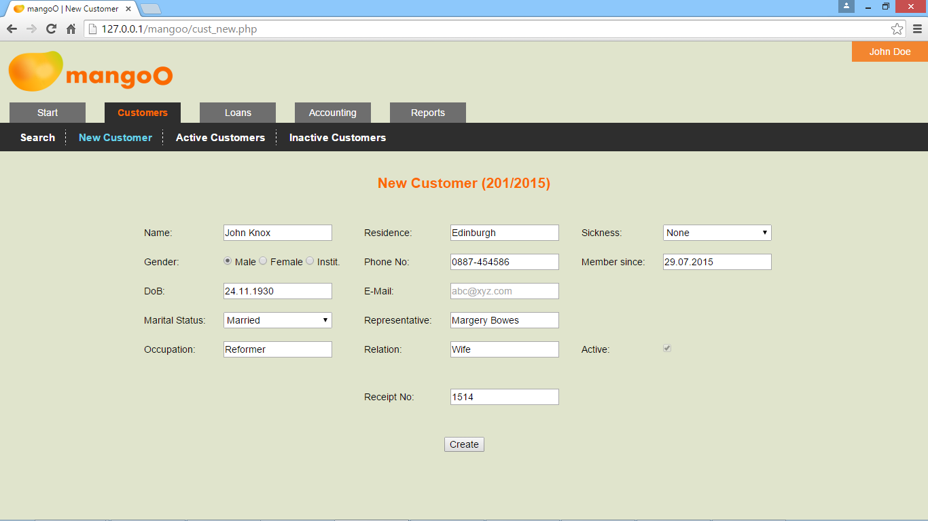
Customer numbers are automatically generated and assigned by the system and cannot be altered by the user.
The fields for name, date of birth, place of residence, and phone number are compulsory to fill. In addition, mangoO will perform consistency checks on entered phone numbers and email addresses.
The system will automatically assume the current date to be the date when the new customer registered with the institution. In case the customer joined at an earlier date, you may adjust the value of Member since accordingly. Please note that throughout mangoO, all dates must be given in the format DD.MM.YYYY (for example 03.01.2016).
New customers are by definition considered to be active. Thus, the activity status cannot be changed on registration. Finally, a receipt number for the entrance fee must be specified.
On clicking Create, the new record will be written to the database.

Predefined Lists for Customers
In addition to the search function, mangoO offers two predefined lists of customers by status.

List of Active Customers
The short link Active Customers will show a list of all customers whose status is currently set to Active. You may access a particular record by clicking the respective customer number.
Clicking Export Active Customers above the list will generate an XLS file which can then be altered, printed, sent, or otherwise used outside mangoO.

List of Inactive Customers
The short link Inactive Customers will show a list of all customers whose status is currently inactive. You may access a particular record by clicking the respective customer number.
Clicking Export Inactive Customers above the list will generate an XLS file which can then be altered, printed, sent, or otherwise used outside mangoO.

Customer Details Page
When retrieving a customer's record, either through searching or through selection from one of the lists, mangoO displays all information on the respective customer on a comprehensive details page.

Basic Customer Data
The data fields on the left-hand side show the customer's basic data. They can be changed any time by overwriting the respective field and clicking Update Data.
Every data update will be logged by the system and displayed in Updated on / by. Due to the nature of the information, the data in Member since, Subscription paid until, and Updated on / by cannot be changed manually.

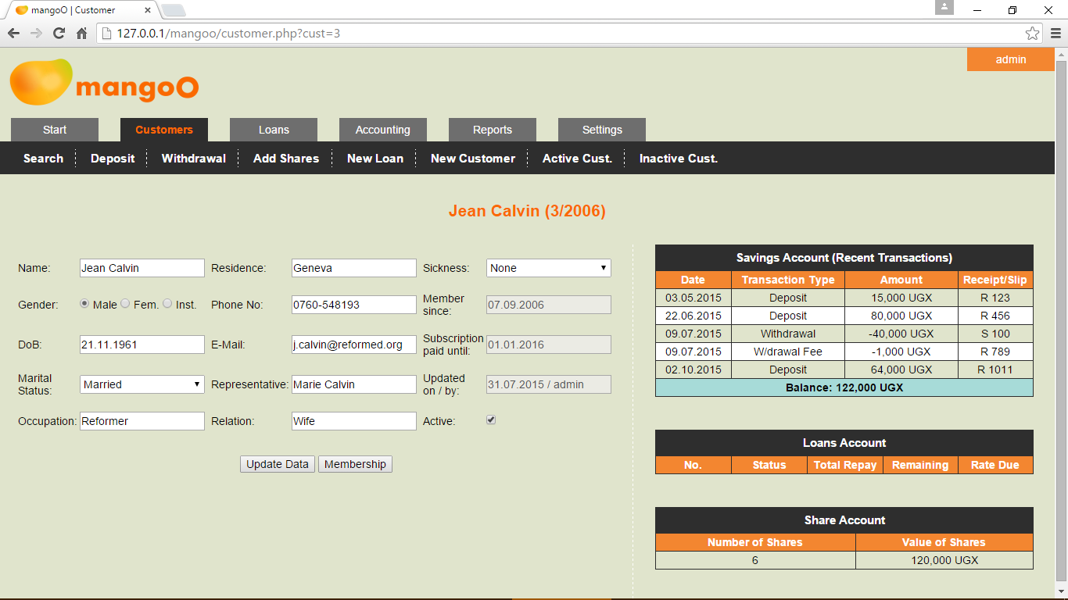
Membership Renewal
In case the annual subscription of a customer has expired, a warning message will appear and mangoO will automatically show a renewal form below the customer's basic data. This form can also be accessed manually by clicking Membership. By default, the system assumes the current date to be the date of membership renewal. Should the customer have renewed his membership earlier, please adjust the date accordingly. You must then specify a receipt number and choose whether or not the subscription fee should be deducted from the customer's savings account.
Clicking Renew Membership will renew the customer's subscription for one year and automatically set his status to active.

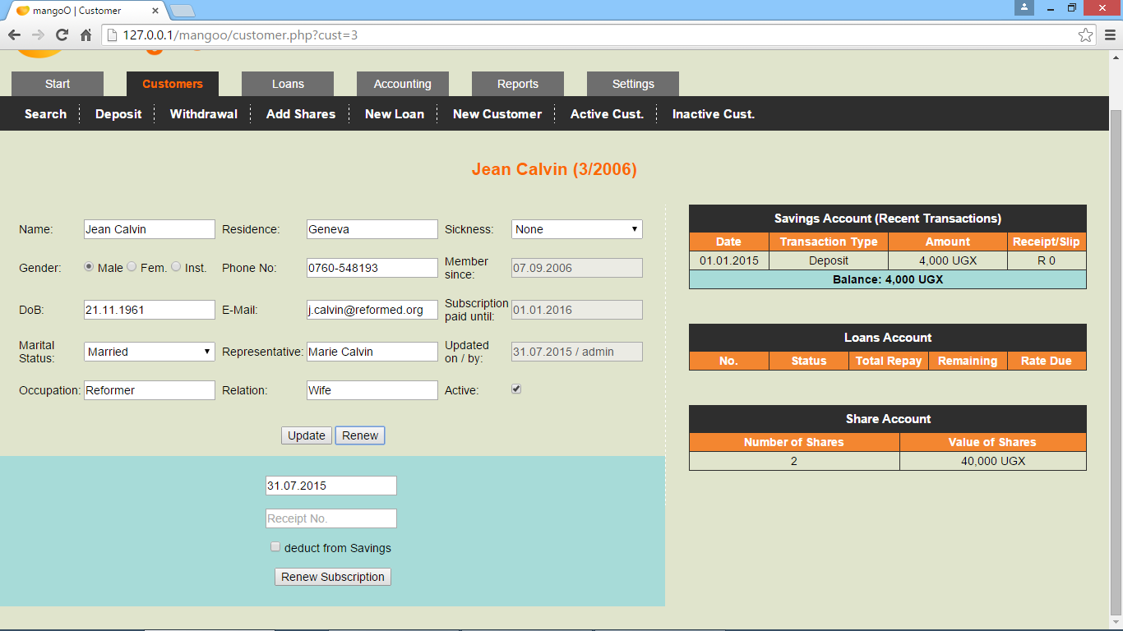
Accounts' Details
The right-hand section provides you with a summary of the customer's accounts. For the sake of space, the savings account table will show the five most recent transactions only. You may access a complete list of all transactions on the savings account by clicking Savings Account in the table header. The shared column for Receipt / Slip numbers indicates the nature of a given number by a preceding R for receipts and a preceding S for withdrawal slips. (See 3.2 for further details on the savings account.)
The loans account table shows all past and recent loans. You can access the details of a particular loan by clicking on the loan number. (See 4 for further details on the loans account.)
Lastly, the share account table gives a summary on the currently owned number of shares and the combined value of these shares. Clicking on Share Account in the table header will take you to the share account with a complete list of all transactions. (See 3.1 for further details on the share account.)

Additional Options in the Menu Bar
When viewing customer details, the menu bar above provides you with a number of different options regarding that respective customer.
The options Deposit and Withdrawal will both take you to the customer's savings account where you may perform either operation (see 3.2).
The Add Shares option will take you to the customer's share account where you may add or transfer shares. (See chapter 3.1 for more information.)
The New Loan option allows you to create a new loan application for the customer (see 4.4).

Account Types
By default, mangoO keeps three different accounts for each customer: Share Account, Savings Account, and Loans Account.

Share Account
You may access a customer's share account either by clicking Share Account in the table header on the customer's details page, or through the Add Shares option in the menu bar above the customer's basic information.

Retrieving account information
The share account page is divided into two sections. The right-hand side will provide you with a comprehensive list of all transactions on the customer's share account. Delete Last Entry below the table allows the user to delete the latest transaction after entering a security captcha. This allows for instant error corrections on the side of the user.
Clicking Export Statement will generate an XLS file containing the complete history of transactions on this account.
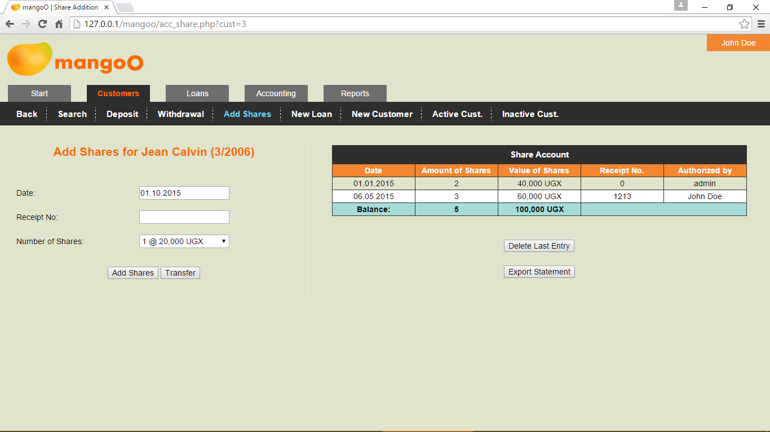

Adding more shares to a customer's account
The form on the left-hand side allows you to add more shares to a customer's account. The system will assume the current date to be the date of share acquisition. In case the customer bought his additional shares at an earlier date, please adjust the date accordingly. Specifying a receipt number for the transaction is compulsory. The drop-down field Number of Shares allows you to choose the number of shares bought by the customer. The system will automatically calculate the amount due, based on the current price for one share. (This information can be edited by authorised users only. See 7 for more details.)

Transfer of shares
In case a customer wishes to terminate his membership with your financial institution, you may use Transfer to transfer shares from another customer to the currently displayed account. In order to do that, please choose from the drop-down field the customer who is ending his membership and click Transfer Shares. The currently displayed customer will then be credited with all the shares previously owned by the leaving customer. The share account of the leaving customer will be set to zero and his membership will be deactivated.

Savings Account
You may access a customer's savings account by either clicking Savings Account in the table header on the customer's details page, or through either the Deposit or the Withdrawal option in the menu bar above the customer's basic information.

Retrieving account information
The savings account page is divided into two sections. The right-hand side will provide you with a comprehensive list of all transactions on the customer's savings account. Delete Last Entry below the table allows the user to delete the latest transaction after entering a security captcha. This allows for instant error corrections on the side of the user.
Clicking Export Statement will generate an XLS file containing the complete history of transactions on this savings account.

Deposits
Depending on the option you chose, the form on the left-hand side allows you to conduct deposits on the customer's savings account. The system will assume the current date to be the date of the transaction. In case the customer deposited at an earlier date, please adjust the date accordingly. Specifying a receipt number for the transaction is compulsory. The amount is to be entered in the bottom-most field.

Withdrawls
Depending on the option you chose, the form on the left-hand side allows you to conduct withdrawals from the customer's savings account. The system will assume the current date to be the date of the transaction. In case the customer withdrew at an earlier date, please adjust the date accordingly. Specifying a withdrawal slip number as well as a receipt number for the transaction is compulsory. The bottom-most checkbox allows you to have the withdrawal fee deducted from the savings account. In this case, the charged fee will appear as a separate transaction on the account, showing the same date, receipt, and slip number as the original withdrawal itself.
Since the withdrawal fee is an income for the financial institution, mangoO will always insert the specified fee for all withdrawals into the incomes record in the accounting section. (The amount of the fee, however, can be edited by authorised users only. See 7 for more information.)
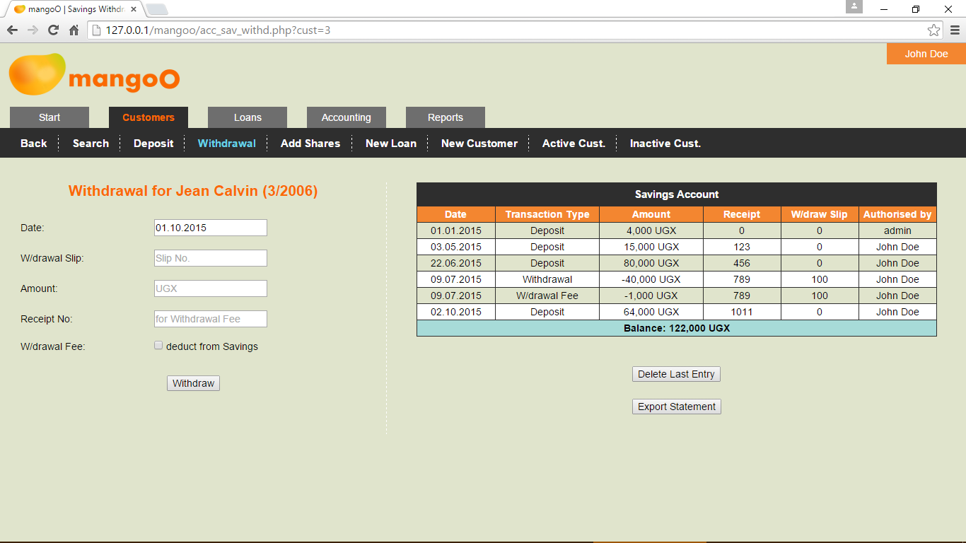

Loans Account
As the Loans Account is the most complex of all account types, the topic of loans is covered in a separate chapter. Therefore, kindly refer to chapter 4 for more information.

Loans
There are two ways of accessing a particular loan. One is to retrieve the details of the respective borrower. In the section displaying a customer's accounts, the loans table will show all past and recent loans. You can access the details of a particular loan by clicking on the loan number. (See also 2.4.3.)
Alternatively, you may search for a particular loan number straightaway. Selecting the Loans tabs will take you to a search form for loans.

Loan Search
The upper input field is used to search for loans by number. Enter the loan number (or part of it) into the input field and click Search Loan. The search result list will show all loans whose numbers match with the specified search term. You may access a particular record by clicking on the respective loan number. If a given number does not exist in the database, the search result list will be empty.
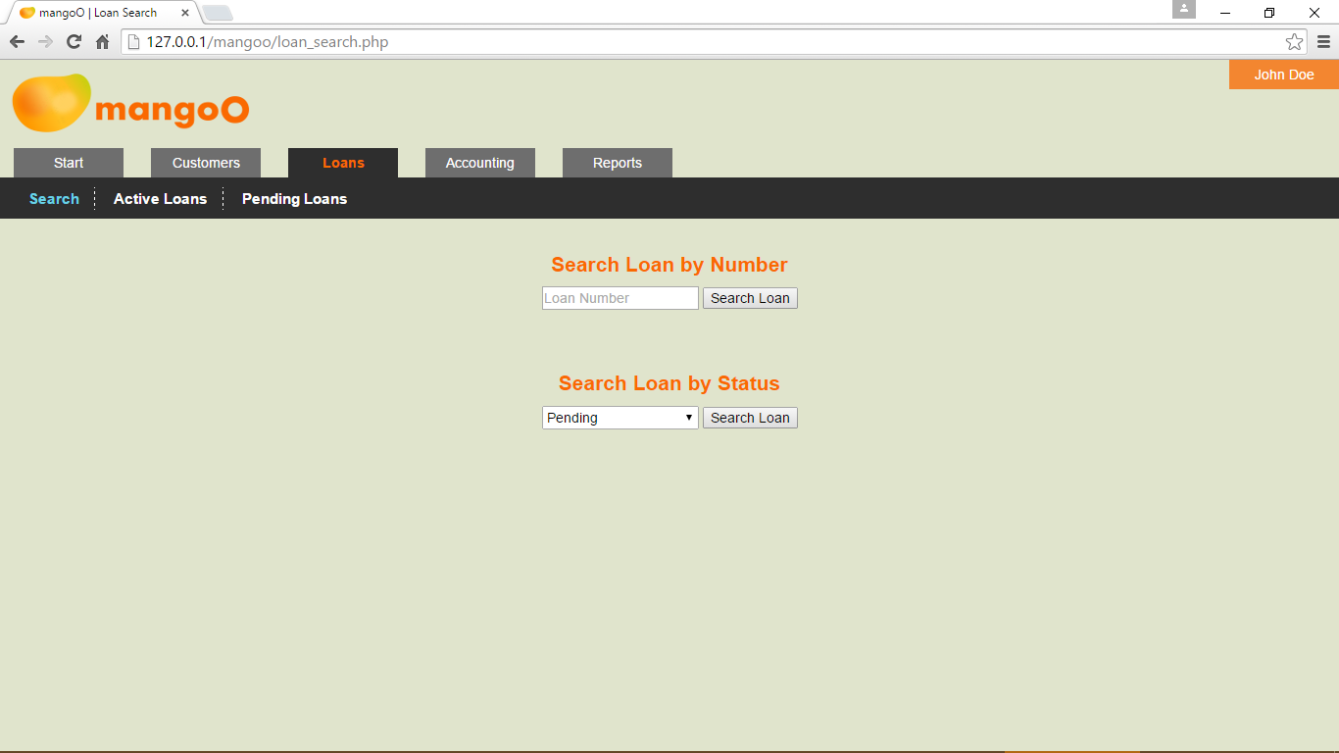
The lower input field allows for searches by status. Select a particular status from the list and click Search Loan. The mangoO system will provide you with a search result list including all loans that have the respective status. You may access a particular record by clicking on the respective loan number.

Predefined Lists for Loans
In addition, mangoO offers two predefined lists of loans by status.

List of Active Loans
The short link Active Loans will show a list of all loans whose status is currently set to active. You may access a particular record by clicking on the respective loan number.
Clicking Export Active Loans above the list will generate an XLS file which can then be altered, printed, sent, or otherwise used outside mangoO.

List of Pending Loans
The short link Pending Loans will show a list of all loans whose status is currently set to pending. You may access a particular record by clicking on the respective loan number.
Clicking Export Pending Loans above the list will generate an XLS file which can then be altered, printed, sent, or otherwise used outside mangoO.

Loan Details Page
After accessing a particular loan, either through searching or through the account of the borrowing customer, mangoO will provide you with a comprehensive overview of all details concerning the respective loan.

Basic Loan Data
The left-hand section of the page presents all basic data about the loan. Apart from the status, none of this information can be changed manually.
In case a document or photograph was attached to one or both securities while entering the loan (see 4.4), those files can be accessed by clicking on the respective security.
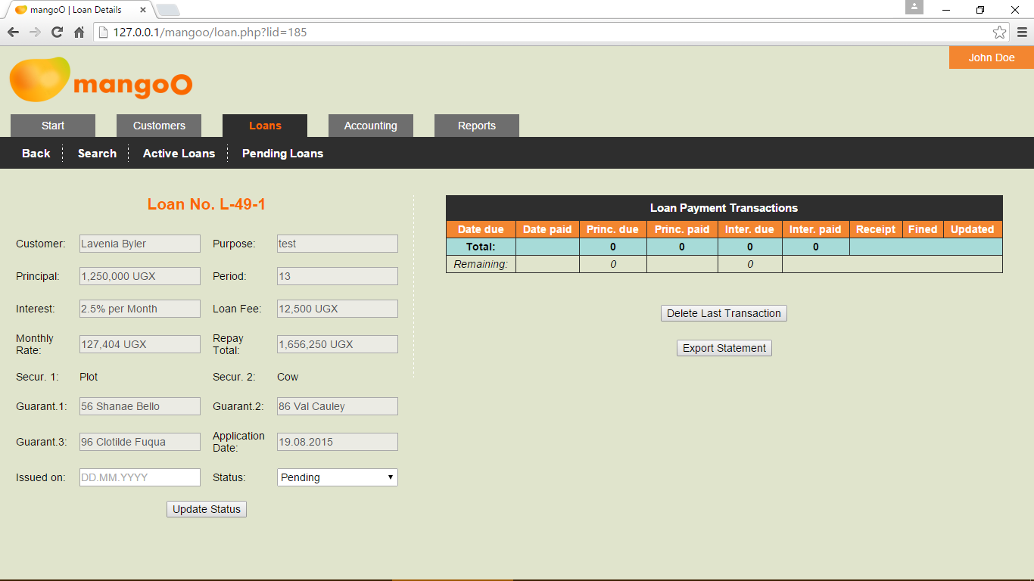
After entering a new loan (see 4.4) into the system, mangoO will automatically have set the status of that loan to Pending. Such a loan is registered because it was applied for by one of the institution's customers. However, a pending loan has not yet been approved, let alone issued.

Rejecting a Pending Loan
On pending loans, the only option is to update the status of that loan. In case a loan application has been rejected, the loan status must be set to Refused and Update Status must be clicked. Please note that even rejected loans will remain on the system for later reference.

Approving a Pending Loan
In case a loan application has been approved, the loan status must be set to Approved. In addition, the date of issuing must be provided in the DD.MM.YYYY format. On clicking Update Status, the system will prompt you to specify the receipt number for the loan fee.
When a loan is approved, mangoO will generate a list of expected loan repayment transactions on the right-hand side of the page (see 4.3.2). Please note that due dates are calculated based on the date of issuing and that 31 days are allowed between payment dates.

Loan Payment Transactions Data
The right-hand section of the page presents data about loan payment transactions. While a loan is still pending, this section will be emtpy. On approval, the system will automatically have generated a list of expected loan repayment transactions (see 4.3.1.2). Please note that due dates are calculated based on the date of issuing and that 31 days are allowed between payment dates.
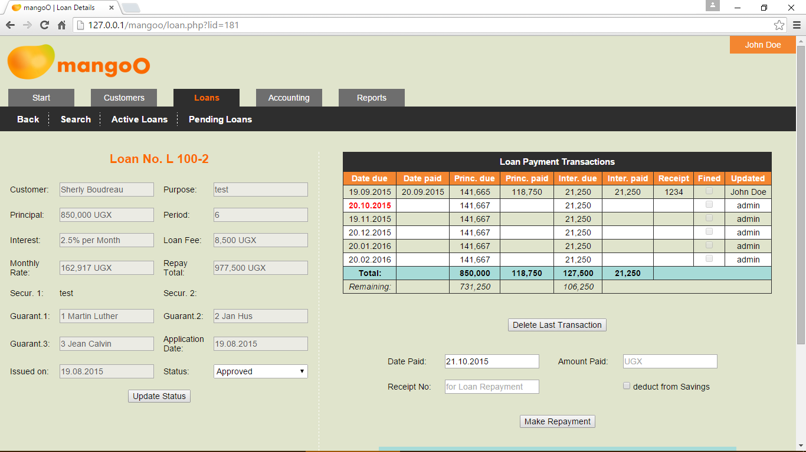

Making a Repayment
In case of a repayment, please enter the date (by default the current date is assumed), the receipt number, and the total amount paid by the customer. Please also indicate whether the amount should be deducted from the customer's savings account.
The system will automatically divide the amount paid based on the idea, that the due interest for the month is always served first. This results in the following rules:
- In case the customers brings less than the due interest, the entire amount will be used to cover interest only.
- In case the customer brings more than the due interest but less than the total expected monthly rate (interest plus principal), interest will be cleared first and the remaining amount will be used on principal.
- In case the customers brings more than the total expected monthly rate, any excess money will be used to clear principal.
- In case a customer brings more than the total outstanding balance on both interest and principal, both positions will be cleared and excess money will be deposited on the customer's savings account.
Any payment of interest will reflect on the incomes side in the accounting section (see 5.2).

Error Correction
The mangoO system allows the user to always revert the last loan payment transaction. When clicking Delete Last Transaction, the system will prompt you to enter a 6-digit security captcha. This is purely a safety function to assure the willful execution of the delete command.

Defaulted Payments and Default Fines
In the Loan Payment Transactions list, due dates which lie in the past and have not been met, are indicated in red. In this case, the system will show a blue box below the payment section which allows you to charge a default fine. To do so, please enter the date (by default the current date is assumed), the receipt number, and the total amount charged as fine. You must also indicate whether the amount should be deducted from the customer's savings account. Kindly note that this is the default setting!
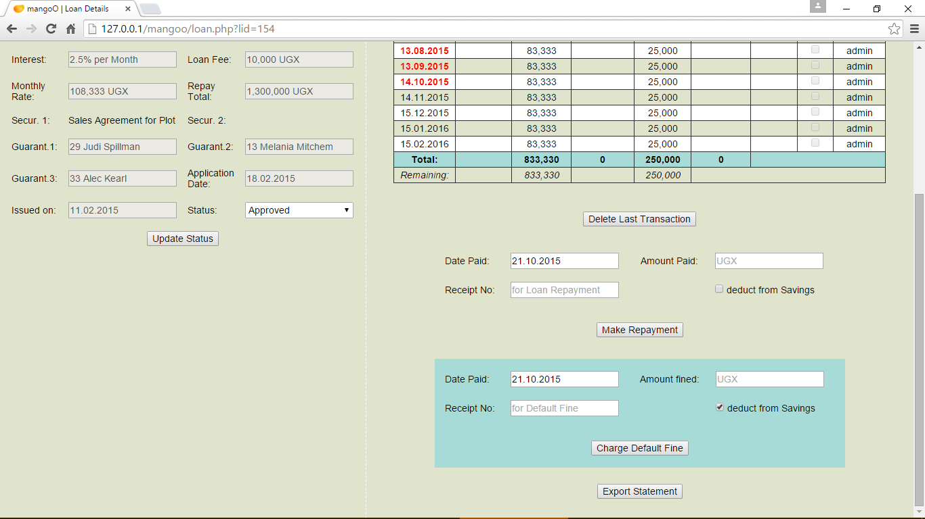
Any payment of a default fine will reflect on the incomes side in the accounting section (see 5.2). Please be aware that mangoO will always assume a default fine to apply to all outstanding transactions. Therefore, all currently defaulted payments will be marked as Fined.

Export Loan Statement
Clicking Export Statement will generate an XLS file containing the complete history of transactions on this particular loan.

Entering a New Loan
In order to enter a new loan application, you first have to open the dataset of the customer (see 2.1) who wishes to apply for the loan. Provided the customer's membership status is Active, you will find an option in the upper menu bar called New Loan . Clicking it will allow you to fill a new loan application for that customer.
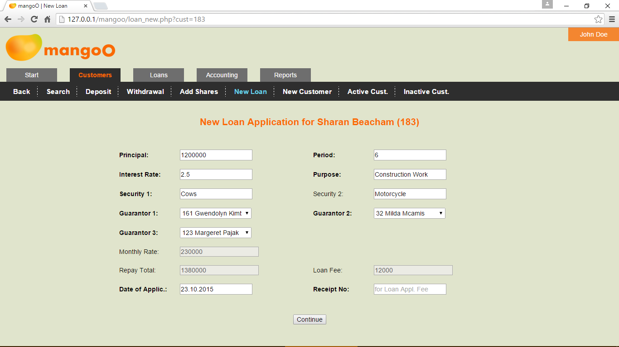
In order to enter a new loan application in the system, fill all compulsory fields. As soon as the information on principal, loan period, and interest rate is entered, mangoO will calculate the monthly repayment rate, the total repay amount, and the applicable loan fee.
By definition, guarantors can only be active members of the institution and must be selected from the lists.
On completion, please click Continue.

Uploading Security Related Documents
The next page allows you to upload documents that further describe the specified securities. Depending on the number of securities, mangoO will offer you one or two option for uploading. You may want to attach photos, scans, or other documents related to the securities. Those documents will later be accessible through the loan's details page (see 4.3.1).
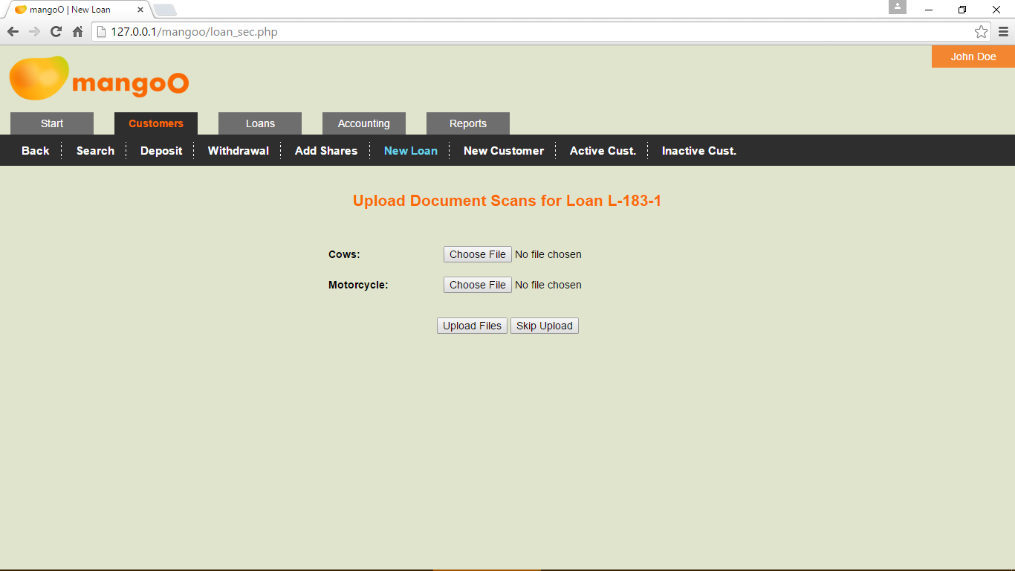
In order to attach any document to a security, click Choose File, navigate to the location of the file on your computer, and select it for upload. The system will only allow you to choose PDF, JPG, JPEG, PNG, TIF, TIFF, DOC, DOCX, XLS, XLSX, ODT, ODS and TXT files.
Clicking Upload Files will upload all selected files to mangoO.
Should you not wish to attach documents to any of the securities, click Skip Upload.

Accounting
mangoO Microfinance Management can also be used for internal accounting purposes. Under Accounting you will find two options New Expenditure and New Income.

Expenditures
Use this option to record all expenditures of your micro-finance institution.
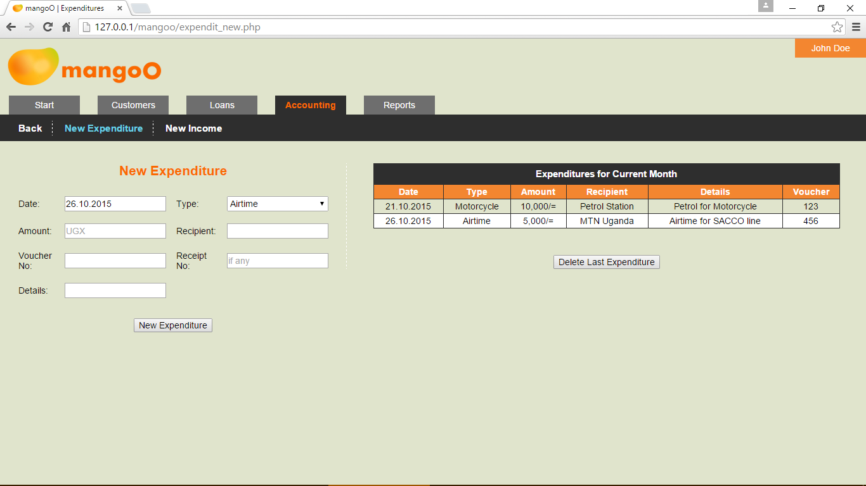
In order to record a new spending, enter all necessary information. Amount, recipient and payment voucher number are compulsory to include. Make sure to also choose an appropriate expenditure type from the list. (Expenditure types can be edited or amended by system administrators only.)
In order to enter the information into the system, click New Expenditure.
On the right-hand side, mangoO shows a list of all expenditures for the current month. Any further representation of accounting data is limited to the Reports section (see 6).
Clicking Delete Last Entry below the table lets the user delete the latest transaction after entering a security captcha. This allows for instant error corrections on the side of the user.

Incomes
WARNING: Under normal circumstances, this option is rarely ever needed! The mangoO system is designed to record all incomes automatically whenever they are generated from the institution's business. This means that payable fees, payments of interest, and other forms of income are captured automatically as they happen. However, instances might occur in which the manual recording of an income is inevitable. In this case, use this option to record such an income. Make sure this remains an exceptional incident!
In order to manually record a new income, enter all necessary information. Amount and receipt number are compulsory to include. Make sure to also choose an appropriate income type from the list. (Please note that income types can be edited or amended by system administrators only.)
In order to enter the information into the system, click New Income.
On the right-hand side, mangoO shows a list of all incomes for the current month. Further representation of accounting data is limited to the Reports section (see 6).
Clicking Delete Last Entry below the table lets the user delete the latest transaction after entering a security captcha. This allows for instant error corrections on the side of the user. Please keep in mind that this will also delete the very transaction that generated this income on the respective customer's account!

Reports
Reporting is used to evaluate the institution's business activities. As this would typically be the work of management staff only, access to these reports is restricted to certain user accounts.
mangoO offers four different types of reports: Incomes, Expenditures, Loans, and Capital. In order to generate a report, choose a type, select a timeperiod and the desired format in the light-blue menu bar, and click Select Report. By default, mangoO offers to generate a report for the previous month.
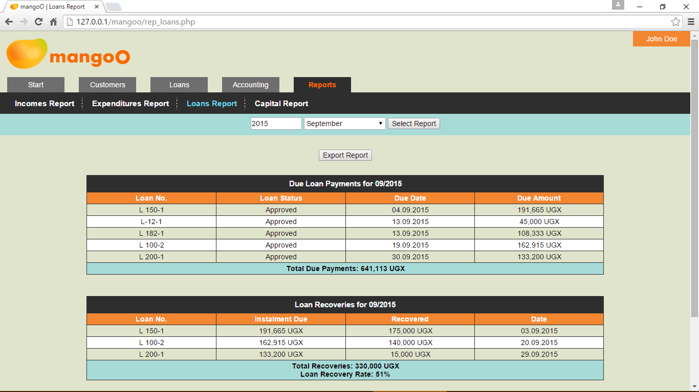
Clicking Export Report above the list will generate an XLS file which can then be altered, printed, sent, or otherwise used outside mangoO.
Further types of reports can be programmed by the system administrator or your supplier.

Settings
Please note that access to the system settings page is limited to users with the respective permission.

Log Records
On clicking Settings, mangoO will take first you the list of Log Records. This list allows to monitor login and logoff activities of all mangoO users. In case a user forgot to log out from the system and his session was forcibly ended, the logoff time will show in red.

General Settings
This page shows several options concerning to system in general. Among those are the current value of shares, the minimum savings account balance, the maximum and minimum loan principal amounts, and others.

Fees
This section allows you to adjust all fees charged by your institution, such as entry fee, loan application fee, loan fee, withdrawal fee, and others.

Users
On this page, existing users can be edited as well as new ones added to mangoO. In order to create a new mangoO user, just fill the fields on the left-hand side of the page. Remember that each user must be assigned to a user group (see 7.5).
In order to edit an existing user, click the Edit-symbol next to the user's record in the right-hand section of the page. Whenever you edit an existing user, make sure to also re-type the password, even when you did not change it.

Usergroups
The permissions management of mangoO is based on user groups. On this page, existing usergroups can be edited as well as new ones added to mangoO. In order to create a new usergroup, just fill the fields on the left-hand side of the page. Choose the appropriate permissions for each group by using the checkboxes.
In order to edit an existing usergroup, click the Edit-symbol next to the usergroup's record in the right-hand section of the page. Remember that when changing permissions for a usergroup, all users in this group will be assigned the new permission settings.

